**北京科技大学 计算机与通信工程学院**

**实 验 报 告**

**实验名称**：__________状态机实验___________

**学生姓名**：__________唐誉源_______________

**专 业**：_________计算机技术与科学_________

**班 级**：____________计1503_______________

**学 号**：____________41503302______________

**指导教师**：__________何杰__________________

**实验成绩**：________________________________

**实验地点**：__________机电楼304_____________

**实验时间**：___2017______年__3_月__15__日

**一、实验目的与实验要求**

**1、实验目的**

本实验的目的是学习时序逻辑模块在数字系统中的综合应用与程序编写并且掌握实验平台的外部功能模块在数字系统设计中的应用。学习SRAM的使用，为设计复杂的数字电路，尤其是CPU设计奠定基础。

**2、实验要求**

1） 在实验报告中提交上述实验内容的 Verilog 代码、仿真结果图、RTL 详细

设 计 图 （ 参 考 Vivado-Design-Flow.pdf 第 11 页 Open Elaborated

Design—>Schematic）、综合实现图（参考 Vivado-Design-Flow.pdf 第 13 页

Open Synthesized Design—>Schematic）以及实验现象图（照片）；

2） 提交实验报告和完整的工程文件。

**二、实验设备（环境）及要求**

实验室提供Windows 7操作系统下的Xilinx开发平台vivado2015.4环境，以及EGO开发板。

**三、实验内容与步骤**

**1、实验1**

（1）实验内容

在七段数码管上滚动显示学号：按照“4 实验步骤——在七段数码管上滚动显示学号” 完成本实验。以学号40123456为例：

1. 首先将学号中的数字被存储在一个32位的寄存器msgArray中；
2. 4个数码管始终显示寄存器的低16位数据；
3. 用频率为3Hz的时钟控制7段数码循环显示：在时钟的上升沿进行向左循环移动4位，并显示。注意：记得要把msgArray中的内容，即msgArray [3:0]的内容移到了msgArray [31:28]中。
4. 复位时，寄存器恢复原始存储状态，7段数码管显示第一组4位字符（寄存器中的低16位），即4012；

（2）主要步骤

I 新建Design Source

`timescale 1ns / 1ps

module top(

input clk100mhz,

input clr,

output [3:0]pos,

output [7:0]seg

);

wire clk190hz,clk3hz;

wire [15:0]dataBus;

clkDiv U1(clk100mhz,clk190hz,clk3hz);

GPU U2(clk3hz,clr,dataBus);

segMsg U3(clk190hz,dataBus,pos,seg);

endmodule

module clkDiv(

input clk100mhz,

output clk190hz,

output clk3hz

);

reg [25:0]count = 0;

assign clk190hz = count[18];

assign clk3hz = count[25];

always @(posedge clk100mhz) count<=count+1;

endmodule

module GPU(

input clk3hz,

input clr,

output [15:0]dataBus

);

reg [31:0]msgArray;

parameter NUMBER = 32'h40123456;

assign dataBus = msgArray[31:16];

always @ (posedge clk3hz or posedge clr)

if (!clr)

msgArray <= NUMBER;

else begin

msgArray[3:0] <= msgArray[31:28];

msgArray[31:4] <= msgArray[27:0];

end

endmodule

module segMsg(

input clk190hz,

input [15:0]dataBus,

output reg[3:0]pos,

output reg[7:0]seg

);

reg [1:0]posC;

reg [3:0]dataP;

always @(posedge clk190hz) begin

case (posC)

0:begin

pos <= 4'b0001;

dataP <= dataBus[3:0];

end

1:begin

pos <= 4'b0010;

dataP <= dataBus[7:4];

end

2:begin

pos <=4'b0100;

dataP <=dataBus[11:8];

end

3:begin

pos <=4'b1000;

dataP <=dataBus[15:12];

end

endcase

posC = posC +1;

end

always @ (dataP)

case(dataP)

0: seg = 8'b0011_1111;

1: seg = 8'b0000_0110;

2: seg = 8'b0101_1011;

3: seg = 8'b0100_1111;

4: seg = 8'b0110_0110;

5: seg = 8'b0110_1101;

6: seg = 8'b0111_1101;

7: seg = 8'b0000_0111;

8: seg = 8'b0111_1111;

9: seg = 8'b0110_1111;

10: seg = 8'b0100_0000;

11: seg = 8'b0000_0000;

default : seg = 8'b0000_1000;

endcase

endmodule

II 添加约束文件

set_property IOSTANDARD LVCMOS33 [get_ports {pos[3]}]

set_property IOSTANDARD LVCMOS33 [get_ports {pos[2]}]

set_property IOSTANDARD LVCMOS33 [get_ports {pos[1]}]

set_property IOSTANDARD LVCMOS33 [get_ports {pos[0]}]

set_property IOSTANDARD LVCMOS33 [get_ports {seg[7]}]

set_property IOSTANDARD LVCMOS33 [get_ports {seg[6]}]

set_property IOSTANDARD LVCMOS33 [get_ports {seg[5]}]

set_property IOSTANDARD LVCMOS33 [get_ports {seg[4]}]

set_property IOSTANDARD LVCMOS33 [get_ports {seg[3]}]

set_property IOSTANDARD LVCMOS33 [get_ports {seg[2]}]

set_property IOSTANDARD LVCMOS33 [get_ports {seg[1]}]

set_property IOSTANDARD LVCMOS33 [get_ports {seg[0]}]

set_property PACKAGE_PIN G1 [get_ports {pos[3]}]

set_property PACKAGE_PIN F1 [get_ports {pos[2]}]

set_property PACKAGE_PIN E1 [get_ports {pos[1]}]

set_property PACKAGE_PIN G6 [get_ports {pos[0]}]

set_property PACKAGE_PIN H2 [get_ports {seg[7]}]

set_property PACKAGE_PIN D2 [get_ports {seg[6]}]

set_property PACKAGE_PIN E2 [get_ports {seg[5]}]

set_property PACKAGE_PIN F3 [get_ports {seg[4]}]

set_property PACKAGE_PIN F4 [get_ports {seg[3]}]

set_property PACKAGE_PIN D3 [get_ports {seg[2]}]

set_property PACKAGE_PIN E3 [get_ports {seg[1]}]

set_property PACKAGE_PIN D4 [get_ports {seg[0]}]

set_property PACKAGE_PIN P17 [get_ports clk100mhz]

set_property PACKAGE_PIN P5 [get_ports clr]

set_property IOSTANDARD LVCMOS33 [get_ports clk100mhz]

set_property IOSTANDARD LVCMOS33 [get_ports clr]

**2、实验2**

（1）实验内容

通过按键输入学号，并循环显示：

电路功能描述：通过Ego1上的按键输入自己的学号（8位10进制数），并存储在32位的寄存器中；8位10进制数输入完成后，实现类似实验3.1中的滚动显示效果。

除了要求实现上述功能外，还包括如下具体实现上的要求：

1. 整个电路具有复位功能；
2. 8个数码管中，4个数码管用于输入数据后的循环显示，另外4个用于显示当前正在输入的数据。
3. 输入过程可控、实时可视：
   * 用按键或者开关控制输入开始和结束，输入开始后用于循环显示的4个数码管停止循环显示，用于显示输入数据的4个数码管开始显示输入数据；输入结束后用于循环显示的4个数码管开始循环显示输入的学号，用于显示输入数据的4个数码管停止显示输入数据。
   * 用按键切换当前要输入的数据位，切换结果通过用于显示输入数据的4个数码管展示出来，即用户能够通过显示输入数据的4个数码管看出来当前正在输入的是哪一位10进制数。
4. 输入数字的时候进行按键消抖（关于按键防抖的原理，请参考本实验手册的“5.1 实验3.2 相关说明”部分）；
5. **设计具有开放性**，下图仅仅为参考的一种实现效果，不作强求实现一样的效果。
6. 数码管、按键、开关的管脚和控制方式等信息请参考本文件“5.1 实验3.2 相关说明”以及”EGo1使用手册.pdf和EGO1电路原理图.pdf”

（2）主要步骤

I 新建Design Source

`timescale 1ns / 1ps

module top(

input clk100mhz,

input main_switch,

input start_stop_switch,

input high_low_switch,

input [3:0]control,

output [3:0]pos,

output [3:0]sop,

output [7:0]seg1,

output [7:0]seg2

);

wire clk190hz,clk12hz,clk3hz,en;

wire [15:0]dataBus1,dataBus2,dataBusInfo;

wire [3:0]GPUcontrol;

clkDiv U1(clk100mhz,clk190hz,clk12hz,clk3hz);

GPU U2(clk3hz,clk12hz,main_switch,start_stop_switch,high_low_switch,GPUcontrol,en,dataBus1,dataBus2,dataBusInfo);

segMsg U3(clk190hz,dataBus1,dataBus2,dataBusInfo,en,pos,sop,seg1,seg2);

btnDeal U4(clk190hz,control[0],GPUcontrol[0]);

btnDeal U5(clk190hz,control[1],GPUcontrol[1]);

btnDeal U6(clk190hz,control[2],GPUcontrol[2]);

btnDeal U7(clk190hz,control[3],GPUcontrol[3]);

endmodule

module clkDiv(

input clk100mhz,

output clk190hz,

output clk12hz,

output clk3hz

);

reg [25:0]count = 0;

reg [17:0]count1 = 0;

reg [23:0]count2 = 0;

assign clk190hz = count1[17];

assign clk3hz = count[25];

assign clk12hz = count2[23];

always @(posedge clk100mhz) count<=count+1;

always @(posedge clk100mhz) count1<=count1+1;

always @(posedge clk100mhz) count2<=count2+1;

endmodule

module GPU(

input clk3hz,

input clk12hz,

input main_switch,

input start_stop_switch,

input high_low_switch, //control high four number or low four number input

input [3:0]control, //up,right,down,left

output enable, //info or act

output [15:0]dataBus1, //for output

output [15:0]dataBus2, //for input

output [15:0]dataBusInfo

);

reg en;

reg [31:0]constant_msg = 0;

reg [3:0]msgIn = 0;

reg [31:0]msg = 0; //left for output

reg [15:0]msgArrayInfo = 0; //left for information

reg [15:0]msgArray = 0; //right for input

reg [1:0]position = 2'b11; //HSB to LSB

assign enable = en;

assign dataBus1 = msg[31:16];

assign dataBusInfo = msgArrayInfo;

assign dataBus2 = msgArray;

always @ (posedge clk12hz) //change the target input number

if (!start_stop_switch && main_switch) begin

if (control[0] && msgIn !=9) msgIn = msgIn+1;

else if (control[0] && msgIn == 9) msgIn = 0;

else if (control[2] && msgIn != 0) msgIn = msgIn-1;

else if (control[2] && msgIn == 0) msgIn = 9;

else if (control[1]) begin msgIn = 0; position = position-1; end

else if (control[3]) begin msgIn = 0; position = position+1; end

end

always @ (posedge clk3hz) begin

if (!main_switch ) begin //main_switch off

en = 0;

msgArrayInfo = 16'haaaa;

msgArray = 16'hffff;

end

if(main_switch) begin

if (!start_stop_switch) begin //main_switch on, stop

en = 0;

if (high_low_switch) begin //four high-number

msgArray = constant_msg[31:16];

msgArrayInfo = 16'haaaa;

msg = constant_msg;

case (position)

3: begin constant_msg[31:28] = msgIn;

msgArray[15:12] = msgIn;

end

2: begin constant_msg[27:24] = msgIn;

msgArray[11:8] = msgIn;

end

1: begin constant_msg[23:20] = msgIn;

msgArray[7:4] = msgIn;

end

0: begin constant_msg[19:16] = msgIn;

msgArray[3:0] = msgIn;

end

endcase

end

else if (!high_low_switch) begin //four low-number

msgArray = constant_msg[15:0];

msgArrayInfo = 16'hffff;

msg = constant_msg;

case (position)

3: begin constant_msg[15:12] = msgIn;

msgArray[15:12] = msgIn;

end

2: begin constant_msg[11:8] = msgIn;

msgArray[11:8] = msgIn;

end

1: begin constant_msg[7:4] = msgIn;

msgArray[7:4] = msgIn;

end

0: begin constant_msg[3:0] = msgIn;

msgArray[3:0] = msgIn;

end

endcase

end

end

else if (start_stop_switch) begin //start

en = 1;

msg[3:0] <= msg[31:28];

msg[31:4] <= msg[27:0];

end

end

end

endmodule

module segMsg(

input clk190hz,

input [15:0]dataBus1, //out

input [15:0]dataBus2, //in

input [15:0]dataBusInfo,

input en, //1 represent start

output reg[3:0]pos, //left for out

output reg[3:0]sop, //right for in

output reg[7:0]seg1, //left for seg

output reg[7:0]seg2 //right for seg

);

reg [1:0]posC1; //refresh digital tube

reg [1:0]posC2;

reg [3:0]dataP1;

reg [3:0]dataP2;

always @(posedge clk190hz) begin

if (en) begin

case (posC1)

0:begin

pos <= 4'b0001;

dataP1 <= dataBus1[3:0];

end

1:begin

pos <= 4'b0010;

dataP1 <= dataBus1[7:4];

end

2:begin

pos <=4'b0100;

dataP1 <=dataBus1[11:8];

end

3:begin

pos <=4'b1000;

dataP1 <=dataBus1[15:12];

end

endcase

posC1 = posC1 +1;

end

else if (!en) begin

case (posC1)

0:begin

pos <= 4'b0001;

dataP1 <= dataBusInfo[3:0];

end

1:begin

pos <= 4'b0010;

dataP1 <= dataBusInfo[7:4];

end

2:begin

pos <=4'b0100;

dataP1 <=dataBusInfo[11:8];

end

3:begin

pos <=4'b1000;

dataP1 <=dataBusInfo[15:12];

end

endcase

posC1 = posC1 + 1;

end

end

always @(posedge clk190hz) begin

if (en) begin

case (posC2)

0:begin

sop <=4'b0001;

dataP2 <=4'ha;

end

1:begin

sop <=4'b0010;

dataP2 <=4'ha;

end

2:begin

sop <=4'b0100;

dataP2 <=4'ha;

end

3:begin

sop <= 4'b1000;

dataP2 <= 4'ha;

end

endcase

posC2 = posC2 +1;

end

else if (!en) begin

case (posC2)

0:begin

sop <= 4'b0001;

dataP2 <= dataBus2[3:0];

end

1:begin

sop <= 4'b0010;

dataP2 <= dataBus2[7:4];

end

2:begin

sop <=4'b0100;

dataP2 <=dataBus2[11:8];

end

3:begin

sop <=4'b1000;

dataP2 <=dataBus2[15:12];

end

endcase

posC2 = posC2 + 1;

end

end

always @ (dataP1)

case(dataP1)

0: seg1 = 8'b0011_1111;

1: seg1 = 8'b0000_0110;

2: seg1 = 8'b0101_1011;

3: seg1 = 8'b0100_1111;

4: seg1 = 8'b0110_0110;

5: seg1 = 8'b0110_1101;

6: seg1 = 8'b0111_1101;

7: seg1 = 8'b0000_0111;

8: seg1 = 8'b0111_1111;

9: seg1 = 8'b0110_1111;

10: seg1 = 8'b0100_0000;

11: seg1 = 8'b0000_0000;

default : seg1 = 8'b0000_1000;

endcase

always @ (dataP2)

case(dataP2)

0: seg2 = 8'b0011_1111;

1: seg2 = 8'b0000_0110;

2: seg2 = 8'b0101_1011;

3: seg2 = 8'b0100_1111;

4: seg2 = 8'b0110_0110;

5: seg2 = 8'b0110_1101;

6: seg2 = 8'b0111_1101;

7: seg2 = 8'b0000_0111;

8: seg2 = 8'b0111_1111;

9: seg2 = 8'b0110_1111;

10: seg2 = 8'b0100_0000;

11: seg2 = 8'b0000_0000;

default : seg2 = 8'b0000_1000;

endcase

endmodule

module btnDeal(

input clk_190Hz,

input btnIn,

output btnOut

);

reg delay1;

reg delay2;

reg delay3;

always @(posedge clk_190Hz)begin

delay3 = delay2;

delay2 = delay1;

delay1 = btnIn;

end

assign btnOut = delay1 & delay2 & delay3;

endmodule

II 添加约束文件

set_property IOSTANDARD LVCMOS33 [get_ports {control[3]}]

set_property IOSTANDARD LVCMOS33 [get_ports {control[2]}]

set_property IOSTANDARD LVCMOS33 [get_ports {control[1]}]

set_property IOSTANDARD LVCMOS33 [get_ports {control[0]}]

set_property IOSTANDARD LVCMOS33 [get_ports {pos[3]}]

set_property IOSTANDARD LVCMOS33 [get_ports {pos[2]}]

set_property IOSTANDARD LVCMOS33 [get_ports {pos[1]}]

set_property IOSTANDARD LVCMOS33 [get_ports {pos[0]}]

set_property IOSTANDARD LVCMOS33 [get_ports {sop[3]}]

set_property IOSTANDARD LVCMOS33 [get_ports {sop[2]}]

set_property IOSTANDARD LVCMOS33 [get_ports {sop[1]}]

set_property IOSTANDARD LVCMOS33 [get_ports {sop[0]}]

set_property PACKAGE_PIN U4 [get_ports {control[0]}]

set_property PACKAGE_PIN R11 [get_ports {control[1]}]

set_property PACKAGE_PIN R17 [get_ports {control[2]}]

set_property PACKAGE_PIN V1 [get_ports {control[3]}]

set_property PACKAGE_PIN G2 [get_ports {pos[3]}]

set_property PACKAGE_PIN C2 [get_ports {pos[2]}]

set_property PACKAGE_PIN C1 [get_ports {pos[1]}]

set_property PACKAGE_PIN H1 [get_ports {pos[0]}]

set_property PACKAGE_PIN G1 [get_ports {sop[3]}]

set_property PACKAGE_PIN F1 [get_ports {sop[2]}]

set_property PACKAGE_PIN E1 [get_ports {sop[1]}]

set_property PACKAGE_PIN G6 [get_ports {sop[0]}]

set_property IOSTANDARD LVCMOS33 [get_ports {seg1[7]}]

set_property IOSTANDARD LVCMOS33 [get_ports {seg1[6]}]

set_property IOSTANDARD LVCMOS33 [get_ports {seg1[5]}]

set_property IOSTANDARD LVCMOS33 [get_ports {seg1[4]}]

set_property IOSTANDARD LVCMOS33 [get_ports {seg1[3]}]

set_property IOSTANDARD LVCMOS33 [get_ports {seg1[2]}]

set_property IOSTANDARD LVCMOS33 [get_ports {seg1[1]}]

set_property IOSTANDARD LVCMOS33 [get_ports {seg1[0]}]

set_property IOSTANDARD LVCMOS33 [get_ports {seg2[7]}]

set_property IOSTANDARD LVCMOS33 [get_ports {seg2[6]}]

set_property IOSTANDARD LVCMOS33 [get_ports {seg2[5]}]

set_property IOSTANDARD LVCMOS33 [get_ports {seg2[4]}]

set_property IOSTANDARD LVCMOS33 [get_ports {seg2[3]}]

set_property IOSTANDARD LVCMOS33 [get_ports {seg2[2]}]

set_property IOSTANDARD LVCMOS33 [get_ports {seg2[1]}]

set_property IOSTANDARD LVCMOS33 [get_ports {seg2[0]}]

set_property PACKAGE_PIN B4 [get_ports {seg1[0]}]

set_property PACKAGE_PIN A4 [get_ports {seg1[1]}]

set_property PACKAGE_PIN A3 [get_ports {seg1[2]}]

set_property PACKAGE_PIN B1 [get_ports {seg1[3]}]

set_property PACKAGE_PIN A1 [get_ports {seg1[4]}]

set_property PACKAGE_PIN B3 [get_ports {seg1[5]}]

set_property PACKAGE_PIN B2 [get_ports {seg1[6]}]

set_property PACKAGE_PIN D5 [get_ports {seg1[7]}]

set_property PACKAGE_PIN D4 [get_ports {seg2[0]}]

set_property PACKAGE_PIN E3 [get_ports {seg2[1]}]

set_property PACKAGE_PIN D3 [get_ports {seg2[2]}]

set_property PACKAGE_PIN F4 [get_ports {seg2[3]}]

set_property PACKAGE_PIN F3 [get_ports {seg2[4]}]

set_property PACKAGE_PIN E2 [get_ports {seg2[5]}]

set_property PACKAGE_PIN D2 [get_ports {seg2[6]}]

set_property PACKAGE_PIN H2 [get_ports {seg2[7]}]

set_property PACKAGE_PIN P17 [get_ports clk100mhz]

set_property IOSTANDARD LVCMOS33 [get_ports clk100mhz]

set_property IOSTANDARD LVCMOS33 [get_ports high_low_switch]

set_property IOSTANDARD LVCMOS33 [get_ports main_switch]

set_property IOSTANDARD LVCMOS33 [get_ports start_stop_switch]

set_property PACKAGE_PIN P5 [get_ports main_switch]

set_property PACKAGE_PIN P4 [get_ports start_stop_switch]

set_property PACKAGE_PIN P3 [get_ports high_low_switch]

**3、实验3**

（1）实验内容

SRAM芯片数据存取：在实验3.2的基础上实现将输入的数据存入FPGA的SRAM芯片上，当进行读取时将数据从SRAM芯片中取出来。

（2）主要步骤

I 新建Design Source(在实验2基础下修改top文件，增加SRAM模块)

`timescale 1ns / 1ps

module top(

input clk100mhz,

input main_switch,

input start_stop_switch,

input high_low_switch,

//input Sram_switch,

input SramWrite_Read,

input chooseAddr,

//input SramReadEnable,

input [3:0]control,

inout [15:0]dataBus,

output [18:0]addrBus,

output chipEnable,upEnable,lowEnable,

output write_read,outEnable,

output [15:0]LED,

output [3:0]pos,

output [3:0]sop,

output [7:0]seg1,

output [7:0]seg2

);

wire clk190hz,clk12hz,clk3hz,clk75hz,en;

wire [15:0]dataBus1,dataBus2,dataBusInfo;

wire [3:0]GPUcontrol;

clkDiv U1(clk100mhz,clk190hz,clk12hz,clk3hz);

GPU

U2(clk3hz,clk12hz,main_switch,start_stop_switch,high_low_switch,GPUcontrol,en,da

taBus1,dataBus2,dataBusInfo);

segMsg U3(clk190hz,dataBus1,dataBus2,dataBusInfo,en,pos,sop,seg1,seg2);

btnDeal U4(clk190hz,control[0],GPUcontrol[0]);

btnDeal U5(clk190hz,control[1],GPUcontrol[1]);

btnDeal U6(clk190hz,control[2],GPUcontrol[2]);

btnDeal U7(clk190hz,control[3],GPUcontrol[3]);

SRAM

U8(clk100mhz,SramWrite_Read,chooseAddr,dataBus2,dataBus,addrBus,chipEnable,upE

nable,lowEnable,write_read,outEnable,LED);

endmodule

`timescale 1ns / 1ps

module SRAM(

input clk100mhz,

input enable,

input chooseAddr,

input [15:0]data,

inout [15:0]dataBus,

output reg[18:0]addrBus,

output chipEnable,upEnable,lowEnable,

output write_read,outEnable,

output [15:0]LED

);

reg [15:0]LED;

reg write_read;

reg outEnable;

reg [15:0]tempdata;

assign dataBus = tempdata;

assign chipEnable = 0;

assign upEnable = 0;

assign lowEnable = 0;

always @ (posedge clk100mhz) begin

case (chooseAddr)

0: addrBus <= 19'b000_0000_0000_0000_0000;

1: addrBus <= 19'b000_0000_0000_0000_0001;

endcase

end

always @ (posedge clk100mhz) begin

if (enable) begin

write_read <= 1'b0;

outEnable <= 1'b1;

tempdata <= data;

end

else begin

write_read = 1;

outEnable = 0;

end

end

always @ (posedge clk100mhz) begin

write_read <= 1;

LED <= dataBus;

end

endmodule

II 添加约束文件

set_property IOSTANDARD LVCMOS33 [get_ports {control[3]}]

set_property IOSTANDARD LVCMOS33 [get_ports {control[2]}]

set_property IOSTANDARD LVCMOS33 [get_ports {control[1]}]

set_property IOSTANDARD LVCMOS33 [get_ports {control[0]}]

set_property IOSTANDARD LVCMOS33 [get_ports {pos[3]}]

set_property IOSTANDARD LVCMOS33 [get_ports {pos[2]}]

set_property IOSTANDARD LVCMOS33 [get_ports {pos[1]}]

set_property IOSTANDARD LVCMOS33 [get_ports {pos[0]}]

set_property IOSTANDARD LVCMOS33 [get_ports {sop[3]}]

set_property IOSTANDARD LVCMOS33 [get_ports {sop[2]}]

set_property IOSTANDARD LVCMOS33 [get_ports {sop[1]}]

set_property IOSTANDARD LVCMOS33 [get_ports {sop[0]}]

set_property PACKAGE_PIN U4 [get_ports {control[0]}]

set_property PACKAGE_PIN R11 [get_ports {control[1]}]

set_property PACKAGE_PIN R17 [get_ports {control[2]}]

set_property PACKAGE_PIN V1 [get_ports {control[3]}]

set_property PACKAGE_PIN G2 [get_ports {pos[3]}]

set_property PACKAGE_PIN C2 [get_ports {pos[2]}]

set_property PACKAGE_PIN C1 [get_ports {pos[1]}]

set_property PACKAGE_PIN H1 [get_ports {pos[0]}]

set_property PACKAGE_PIN G1 [get_ports {sop[3]}]

set_property PACKAGE_PIN F1 [get_ports {sop[2]}]

set_property PACKAGE_PIN E1 [get_ports {sop[1]}]

set_property PACKAGE_PIN G6 [get_ports {sop[0]}]

set_property IOSTANDARD LVCMOS33 [get_ports {seg1[7]}]

set_property IOSTANDARD LVCMOS33 [get_ports {seg1[6]}]

set_property IOSTANDARD LVCMOS33 [get_ports {seg1[5]}]

set_property IOSTANDARD LVCMOS33 [get_ports {seg1[4]}]

set_property IOSTANDARD LVCMOS33 [get_ports {seg1[3]}]

set_property IOSTANDARD LVCMOS33 [get_ports {seg1[2]}]

set_property IOSTANDARD LVCMOS33 [get_ports {seg1[1]}]

set_property IOSTANDARD LVCMOS33 [get_ports {seg1[0]}]

set_property IOSTANDARD LVCMOS33 [get_ports {seg2[7]}]

set_property IOSTANDARD LVCMOS33 [get_ports {seg2[6]}]

set_property IOSTANDARD LVCMOS33 [get_ports {seg2[5]}]

set_property IOSTANDARD LVCMOS33 [get_ports {seg2[4]}]

set_property IOSTANDARD LVCMOS33 [get_ports {seg2[3]}]

set_property IOSTANDARD LVCMOS33 [get_ports {seg2[2]}]

set_property IOSTANDARD LVCMOS33 [get_ports {seg2[1]}]

set_property IOSTANDARD LVCMOS33 [get_ports {seg2[0]}]

set_property PACKAGE_PIN B4 [get_ports {seg1[0]}]

set_property PACKAGE_PIN A4 [get_ports {seg1[1]}]

set_property PACKAGE_PIN A3 [get_ports {seg1[2]}]

set_property PACKAGE_PIN B1 [get_ports {seg1[3]}]

set_property PACKAGE_PIN A1 [get_ports {seg1[4]}]

set_property PACKAGE_PIN B3 [get_ports {seg1[5]}]

set_property PACKAGE_PIN B2 [get_ports {seg1[6]}]

set_property PACKAGE_PIN D5 [get_ports {seg1[7]}]

set_property PACKAGE_PIN D4 [get_ports {seg2[0]}]

set_property PACKAGE_PIN E3 [get_ports {seg2[1]}]

set_property PACKAGE_PIN D3 [get_ports {seg2[2]}]

set_property PACKAGE_PIN F4 [get_ports {seg2[3]}]

set_property PACKAGE_PIN F3 [get_ports {seg2[4]}]

set_property PACKAGE_PIN E2 [get_ports {seg2[5]}]

set_property PACKAGE_PIN D2 [get_ports {seg2[6]}]

set_property PACKAGE_PIN H2 [get_ports {seg2[7]}]

set_property PACKAGE_PIN P17 [get_ports clk100mhz]

set_property IOSTANDARD LVCMOS33 [get_ports clk100mhz]

set_property IOSTANDARD LVCMOS33 [get_ports high_low_switch]

set_property IOSTANDARD LVCMOS33 [get_ports main_switch]

set_property IOSTANDARD LVCMOS33 [get_ports start_stop_switch]

set_property PACKAGE_PIN P5 [get_ports main_switch]

set_property PACKAGE_PIN P4 [get_ports start_stop_switch]

set_property PACKAGE_PIN P3 [get_ports high_low_switch]

set_property IOSTANDARD LVCMOS33 [get_ports {addrBus[18]}]

set_property IOSTANDARD LVCMOS33 [get_ports {addrBus[17]}]

set_property IOSTANDARD LVCMOS33 [get_ports {addrBus[16]}]

set_property IOSTANDARD LVCMOS33 [get_ports {addrBus[15]}]

set_property IOSTANDARD LVCMOS33 [get_ports {addrBus[14]}]

set_property IOSTANDARD LVCMOS33 [get_ports {addrBus[13]}]

set_property IOSTANDARD LVCMOS33 [get_ports {addrBus[12]}]

set_property IOSTANDARD LVCMOS33 [get_ports {addrBus[11]}]

set_property IOSTANDARD LVCMOS33 [get_ports {addrBus[10]}]

set_property IOSTANDARD LVCMOS33 [get_ports {addrBus[9]}]

set_property IOSTANDARD LVCMOS33 [get_ports {addrBus[8]}]

set_property IOSTANDARD LVCMOS33 [get_ports {addrBus[7]}]

set_property IOSTANDARD LVCMOS33 [get_ports {addrBus[6]}]

set_property IOSTANDARD LVCMOS33 [get_ports {addrBus[5]}]

set_property IOSTANDARD LVCMOS33 [get_ports {addrBus[4]}]

set_property IOSTANDARD LVCMOS33 [get_ports {addrBus[3]}]

set_property IOSTANDARD LVCMOS33 [get_ports {addrBus[2]}]

set_property IOSTANDARD LVCMOS33 [get_ports {addrBus[1]}]

set_property IOSTANDARD LVCMOS33 [get_ports {addrBus[0]}]

set_property IOSTANDARD LVCMOS33 [get_ports {LED[15]}]

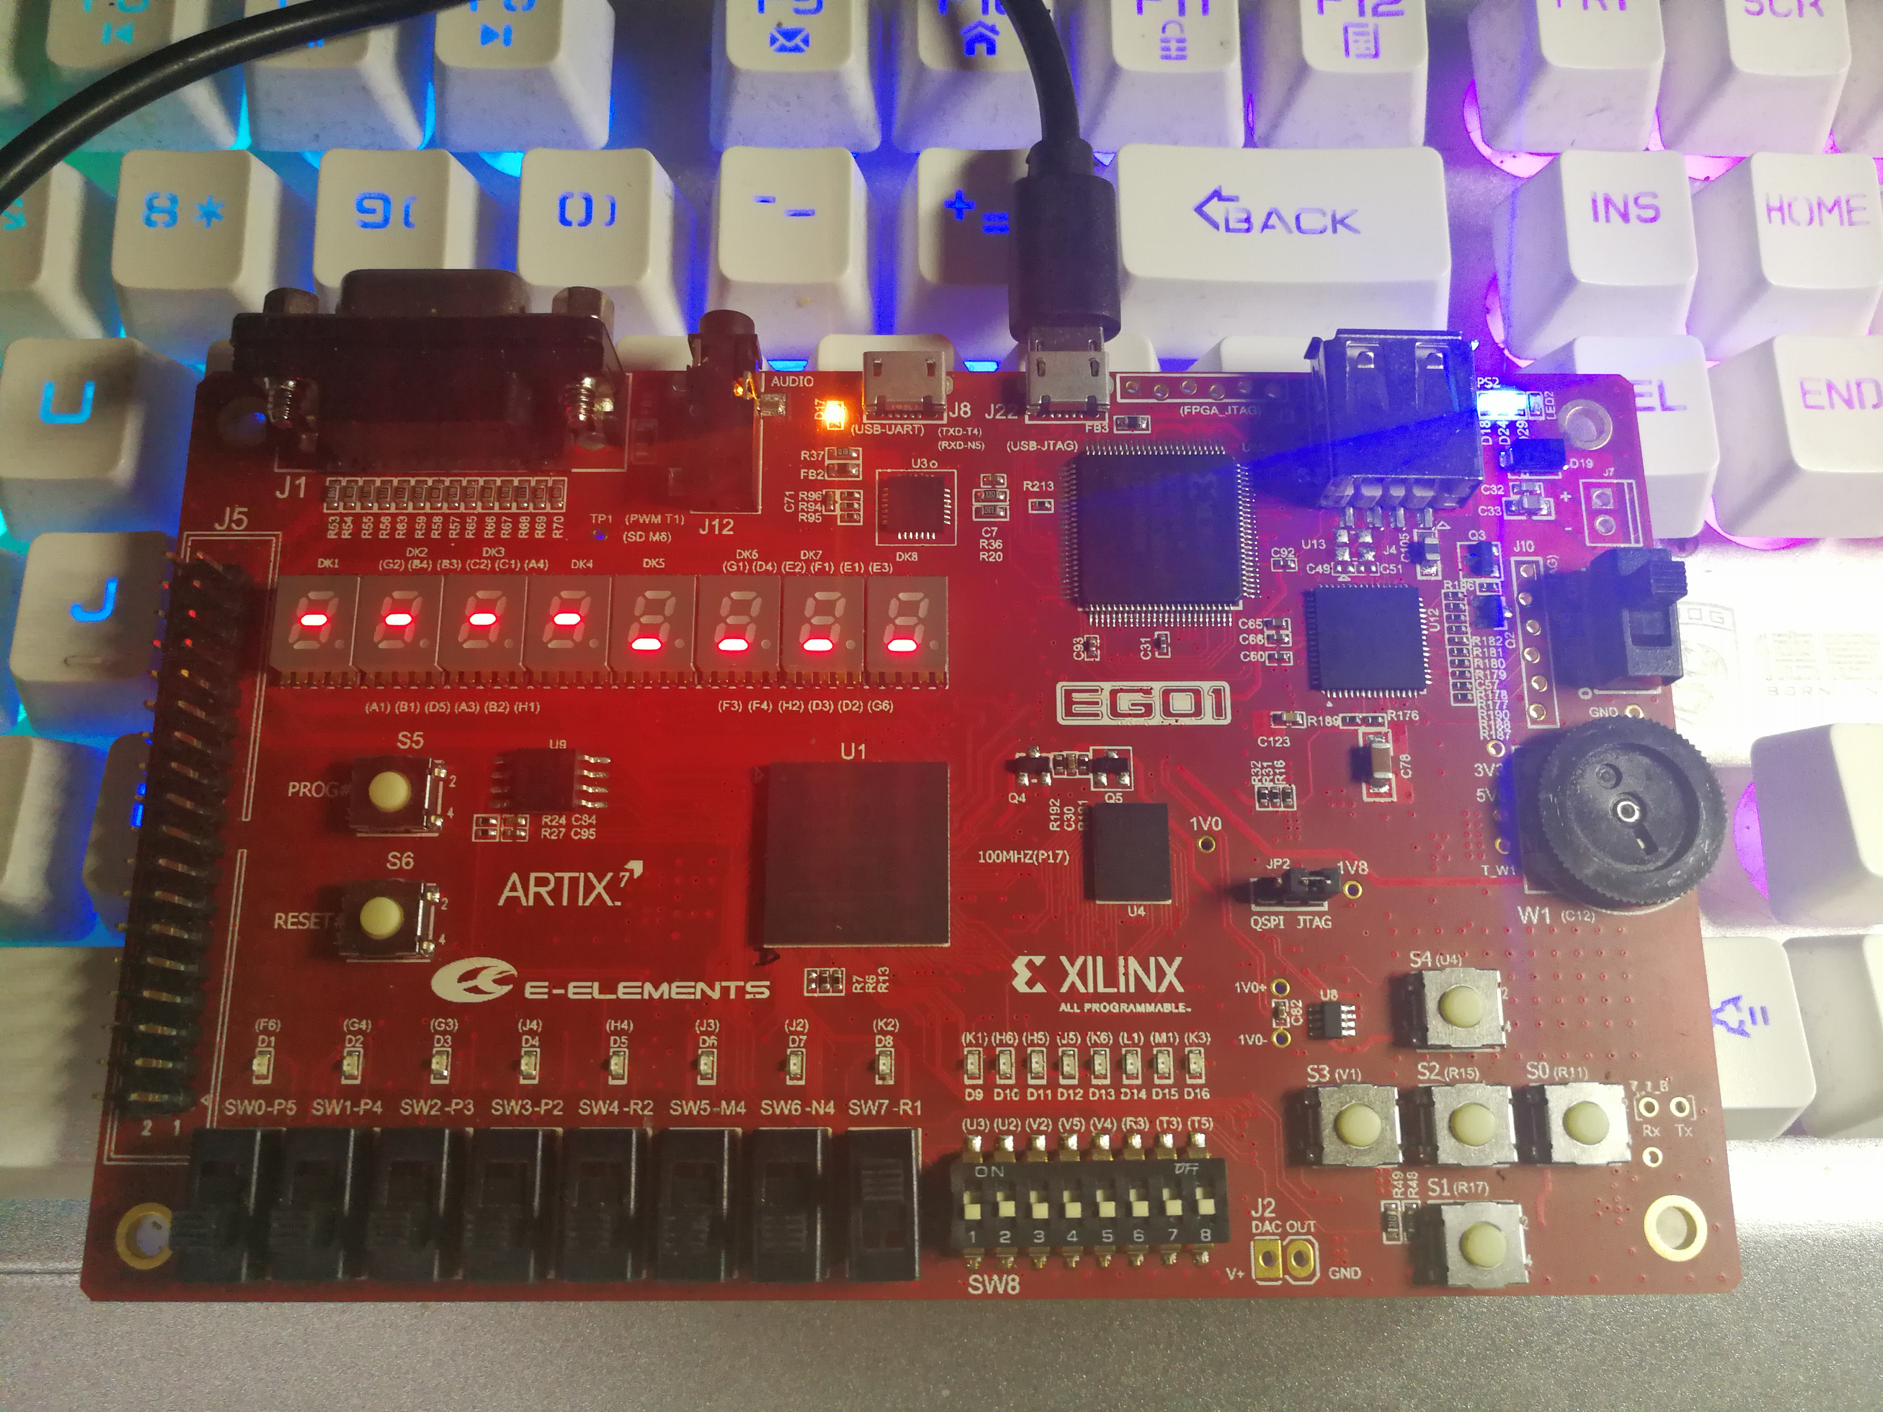set_property IOSTANDARD LVCMOS33 [get_ports {LED[14]}]

set_property IOSTANDARD LVCMOS33 [get_ports {LED[13]}]

set_property IOSTANDARD LVCMOS33 [get_ports {LED[12]}]

set_property IOSTANDARD LVCMOS33 [get_ports {LED[11]}]

set_property IOSTANDARD LVCMOS33 [get_ports {LED[10]}]

set_property IOSTANDARD LVCMOS33 [get_ports {LED[9]}]

set_property IOSTANDARD LVCMOS33 [get_ports {LED[8]}]

set_property IOSTANDARD LVCMOS33 [get_ports {LED[7]}]

set_property IOSTANDARD LVCMOS33 [get_ports {LED[6]}]

set_property IOSTANDARD LVCMOS33 [get_ports {LED[5]}]

set_property IOSTANDARD LVCMOS33 [get_ports {LED[4]}]

set_property IOSTANDARD LVCMOS33 [get_ports {LED[3]}]

set_property IOSTANDARD LVCMOS33 [get_ports {LED[2]}]

set_property IOSTANDARD LVCMOS33 [get_ports {LED[1]}]

set_property IOSTANDARD LVCMOS33 [get_ports {LED[0]}]

set_property PACKAGE_PIN T15 [get_ports {addrBus[0]}]

set_property PACKAGE_PIN T14 [get_ports {addrBus[1]}]

set_property PACKAGE_PIN N16 [get_ports {addrBus[2]}]

set_property PACKAGE_PIN N15 [get_ports {addrBus[3]}]

set_property PACKAGE_PIN M17 [get_ports {addrBus[4]}]

set_property PACKAGE_PIN M16 [get_ports {addrBus[5]}]

set_property PACKAGE_PIN P18 [get_ports {addrBus[6]}]

set_property PACKAGE_PIN N17 [get_ports {addrBus[7]}]

set_property PACKAGE_PIN P14 [get_ports {addrBus[8]}]

set_property PACKAGE_PIN N14 [get_ports {addrBus[9]}]

set_property PACKAGE_PIN T18 [get_ports {addrBus[10]}]

set_property PACKAGE_PIN R18 [get_ports {addrBus[11]}]

set_property PACKAGE_PIN M13 [get_ports {addrBus[12]}]

set_property PACKAGE_PIN R13 [get_ports {addrBus[13]}]

set_property PACKAGE_PIN R12 [get_ports {addrBus[14]}]

set_property PACKAGE_PIN M18 [get_ports {addrBus[15]}]

set_property PACKAGE_PIN L18 [get_ports {addrBus[16]}]

set_property PACKAGE_PIN L16 [get_ports {addrBus[17]}]

set_property PACKAGE_PIN L15 [get_ports {addrBus[18]}]

set_property PACKAGE_PIN F6 [get_ports {LED[15]}]

set_property PACKAGE_PIN G4 [get_ports {LED[14]}]

set_property PACKAGE_PIN G3 [get_ports {LED[13]}]

set_property PACKAGE_PIN J4 [get_ports {LED[12]}]

set_property PACKAGE_PIN H4 [get_ports {LED[11]}]

set_property PACKAGE_PIN J3 [get_ports {LED[10]}]

set_property PACKAGE_PIN J2 [get_ports {LED[9]}]

set_property PACKAGE_PIN K2 [get_ports {LED[8]}]

set_property PACKAGE_PIN K1 [get_ports {LED[7]}]

set_property PACKAGE_PIN H6 [get_ports {LED[6]}]

set_property PACKAGE_PIN H5 [get_ports {LED[5]}]

set_property PACKAGE_PIN J5 [get_ports {LED[4]}]

set_property PACKAGE_PIN K6 [get_ports {LED[3]}]

set_property PACKAGE_PIN L1 [get_ports {LED[2]}]

set_property PACKAGE_PIN M1 [get_ports {LED[1]}]

set_property PACKAGE_PIN K3 [get_ports {LED[0]}]

set_property IOSTANDARD LVCMOS33 [get_ports chipEnable]

set_property PACKAGE_PIN V15 [get_ports chipEnable]

set_property IOSTANDARD LVCMOS33 [get_ports lowEnable]

set_property PACKAGE_PIN R10 [get_ports lowEnable]

set_property IOSTANDARD LVCMOS33 [get_ports outEnable]

set_property PACKAGE_PIN T16 [get_ports outEnable]

set_property IOSTANDARD LVCMOS33 [get_ports write_read]

set_property PACKAGE_PIN V16 [get_ports write_read]

set_property IOSTANDARD LVCMOS33 [get_ports upEnable]

set_property PACKAGE_PIN R16 [get_ports upEnable]

set_property IOSTANDARD LVCMOS33 [get_ports Sram_switch]

set_property PACKAGE_PIN M4 [get_ports Sram_switch]

set_property IOSTANDARD LVCMOS33 [get_ports chooseAddr]

set_property IOSTANDARD LVCMOS33 [get_ports {dataBus[15]}]

set_property IOSTANDARD LVCMOS33 [get_ports {dataBus[14]}]

set_property IOSTANDARD LVCMOS33 [get_ports {dataBus[13]}]

set_property IOSTANDARD LVCMOS33 [get_ports {dataBus[12]}]

set_property IOSTANDARD LVCMOS33 [get_ports {dataBus[11]}]

set_property IOSTANDARD LVCMOS33 [get_ports {dataBus[10]}]

set_property IOSTANDARD LVCMOS33 [get_ports {dataBus[9]}]

set_property IOSTANDARD LVCMOS33 [get_ports {dataBus[8]}]

set_property IOSTANDARD LVCMOS33 [get_ports {dataBus[7]}]

set_property IOSTANDARD LVCMOS33 [get_ports {dataBus[6]}]

set_property IOSTANDARD LVCMOS33 [get_ports {dataBus[5]}]

set_property IOSTANDARD LVCMOS33 [get_ports {dataBus[4]}]

set_property IOSTANDARD LVCMOS33 [get_ports {dataBus[3]}]

set_property IOSTANDARD LVCMOS33 [get_ports {dataBus[2]}]

set_property IOSTANDARD LVCMOS33 [get_ports {dataBus[1]}]

set_property IOSTANDARD LVCMOS33 [get_ports {dataBus[0]}]

set_property IOSTANDARD LVCMOS33 [get_ports SramWrite_Read]

set_property PACKAGE_PIN U17 [get_ports {dataBus[0]}]

set_property PACKAGE_PIN U18 [get_ports {dataBus[1]}]

set_property PACKAGE_PIN U16 [get_ports {dataBus[2]}]

set_property PACKAGE_PIN V17 [get_ports {dataBus[3]}]

set_property PACKAGE_PIN T11 [get_ports {dataBus[4]}]

set_property PACKAGE_PIN U11 [get_ports {dataBus[5]}]

set_property PACKAGE_PIN U12 [get_ports {dataBus[6]}]

set_property PACKAGE_PIN V12 [get_ports {dataBus[7]}]

set_property PACKAGE_PIN V10 [get_ports {dataBus[8]}]

set_property PACKAGE_PIN V11 [get_ports {dataBus[9]}]

set_property PACKAGE_PIN U14 [get_ports {dataBus[10]}]

set_property PACKAGE_PIN V14 [get_ports {dataBus[11]}]

set_property PACKAGE_PIN T13 [get_ports {dataBus[12]}]

set_property PACKAGE_PIN U13 [get_ports {dataBus[13]}]

set_property PACKAGE_PIN T9 [get_ports {dataBus[14]}]

set_property PACKAGE_PIN T10 [get_ports {dataBus[15]}]

set_property PACKAGE_PIN R1 [get_ports SramWrite_Read]

set_property PACKAGE_PIN N4 [get_ports chooseAddr]

**四：实验结果与分析**

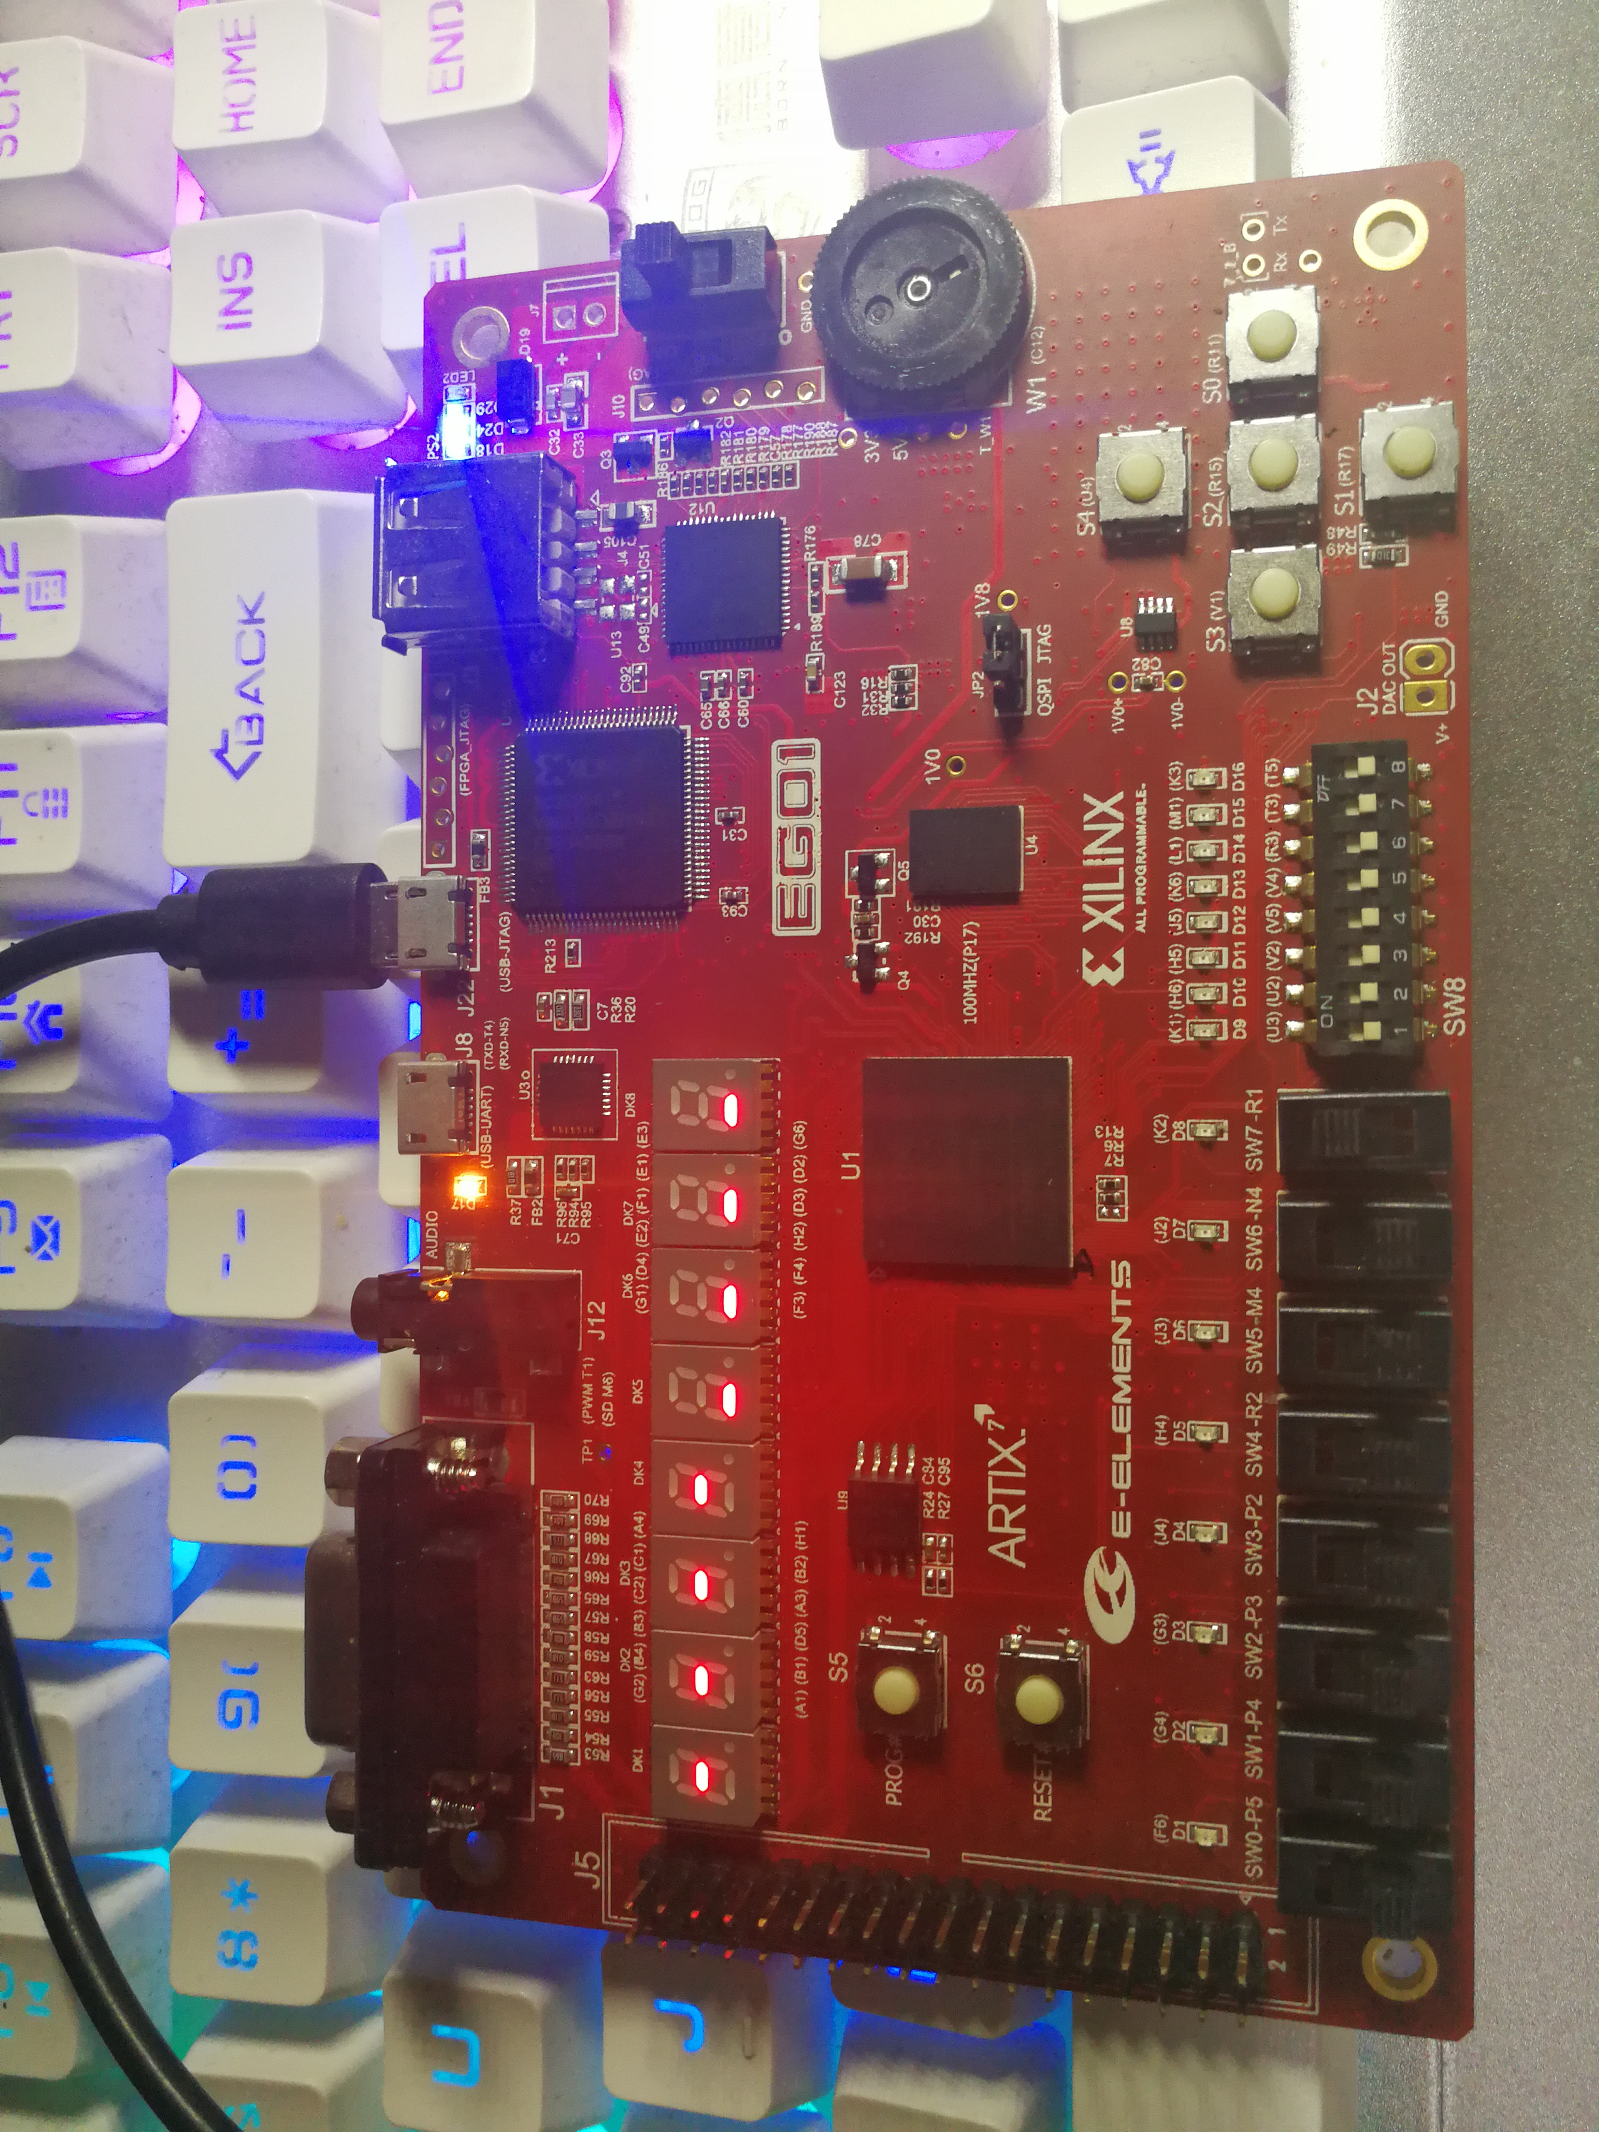

未开启状态

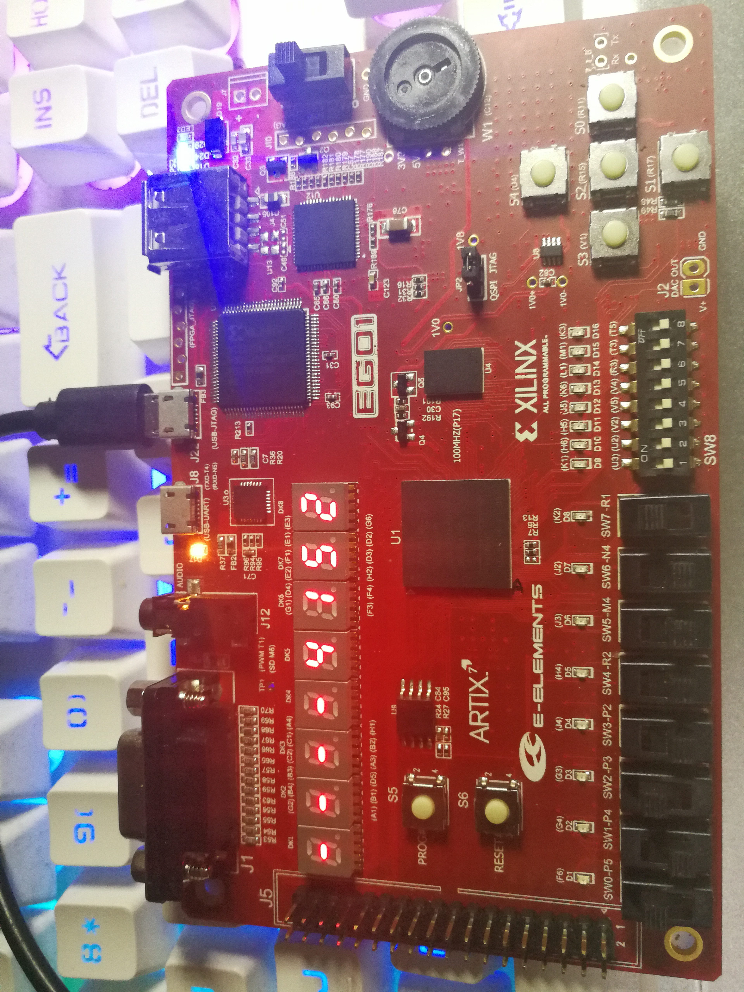

高4位输入

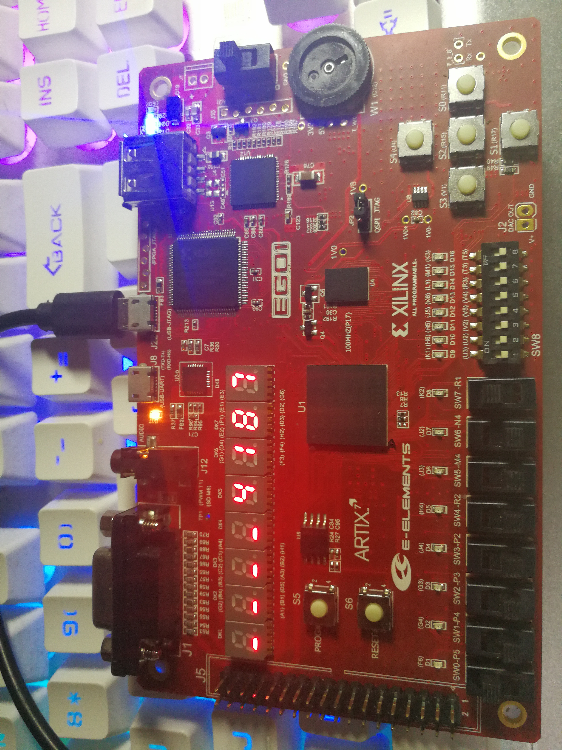

低4位输入

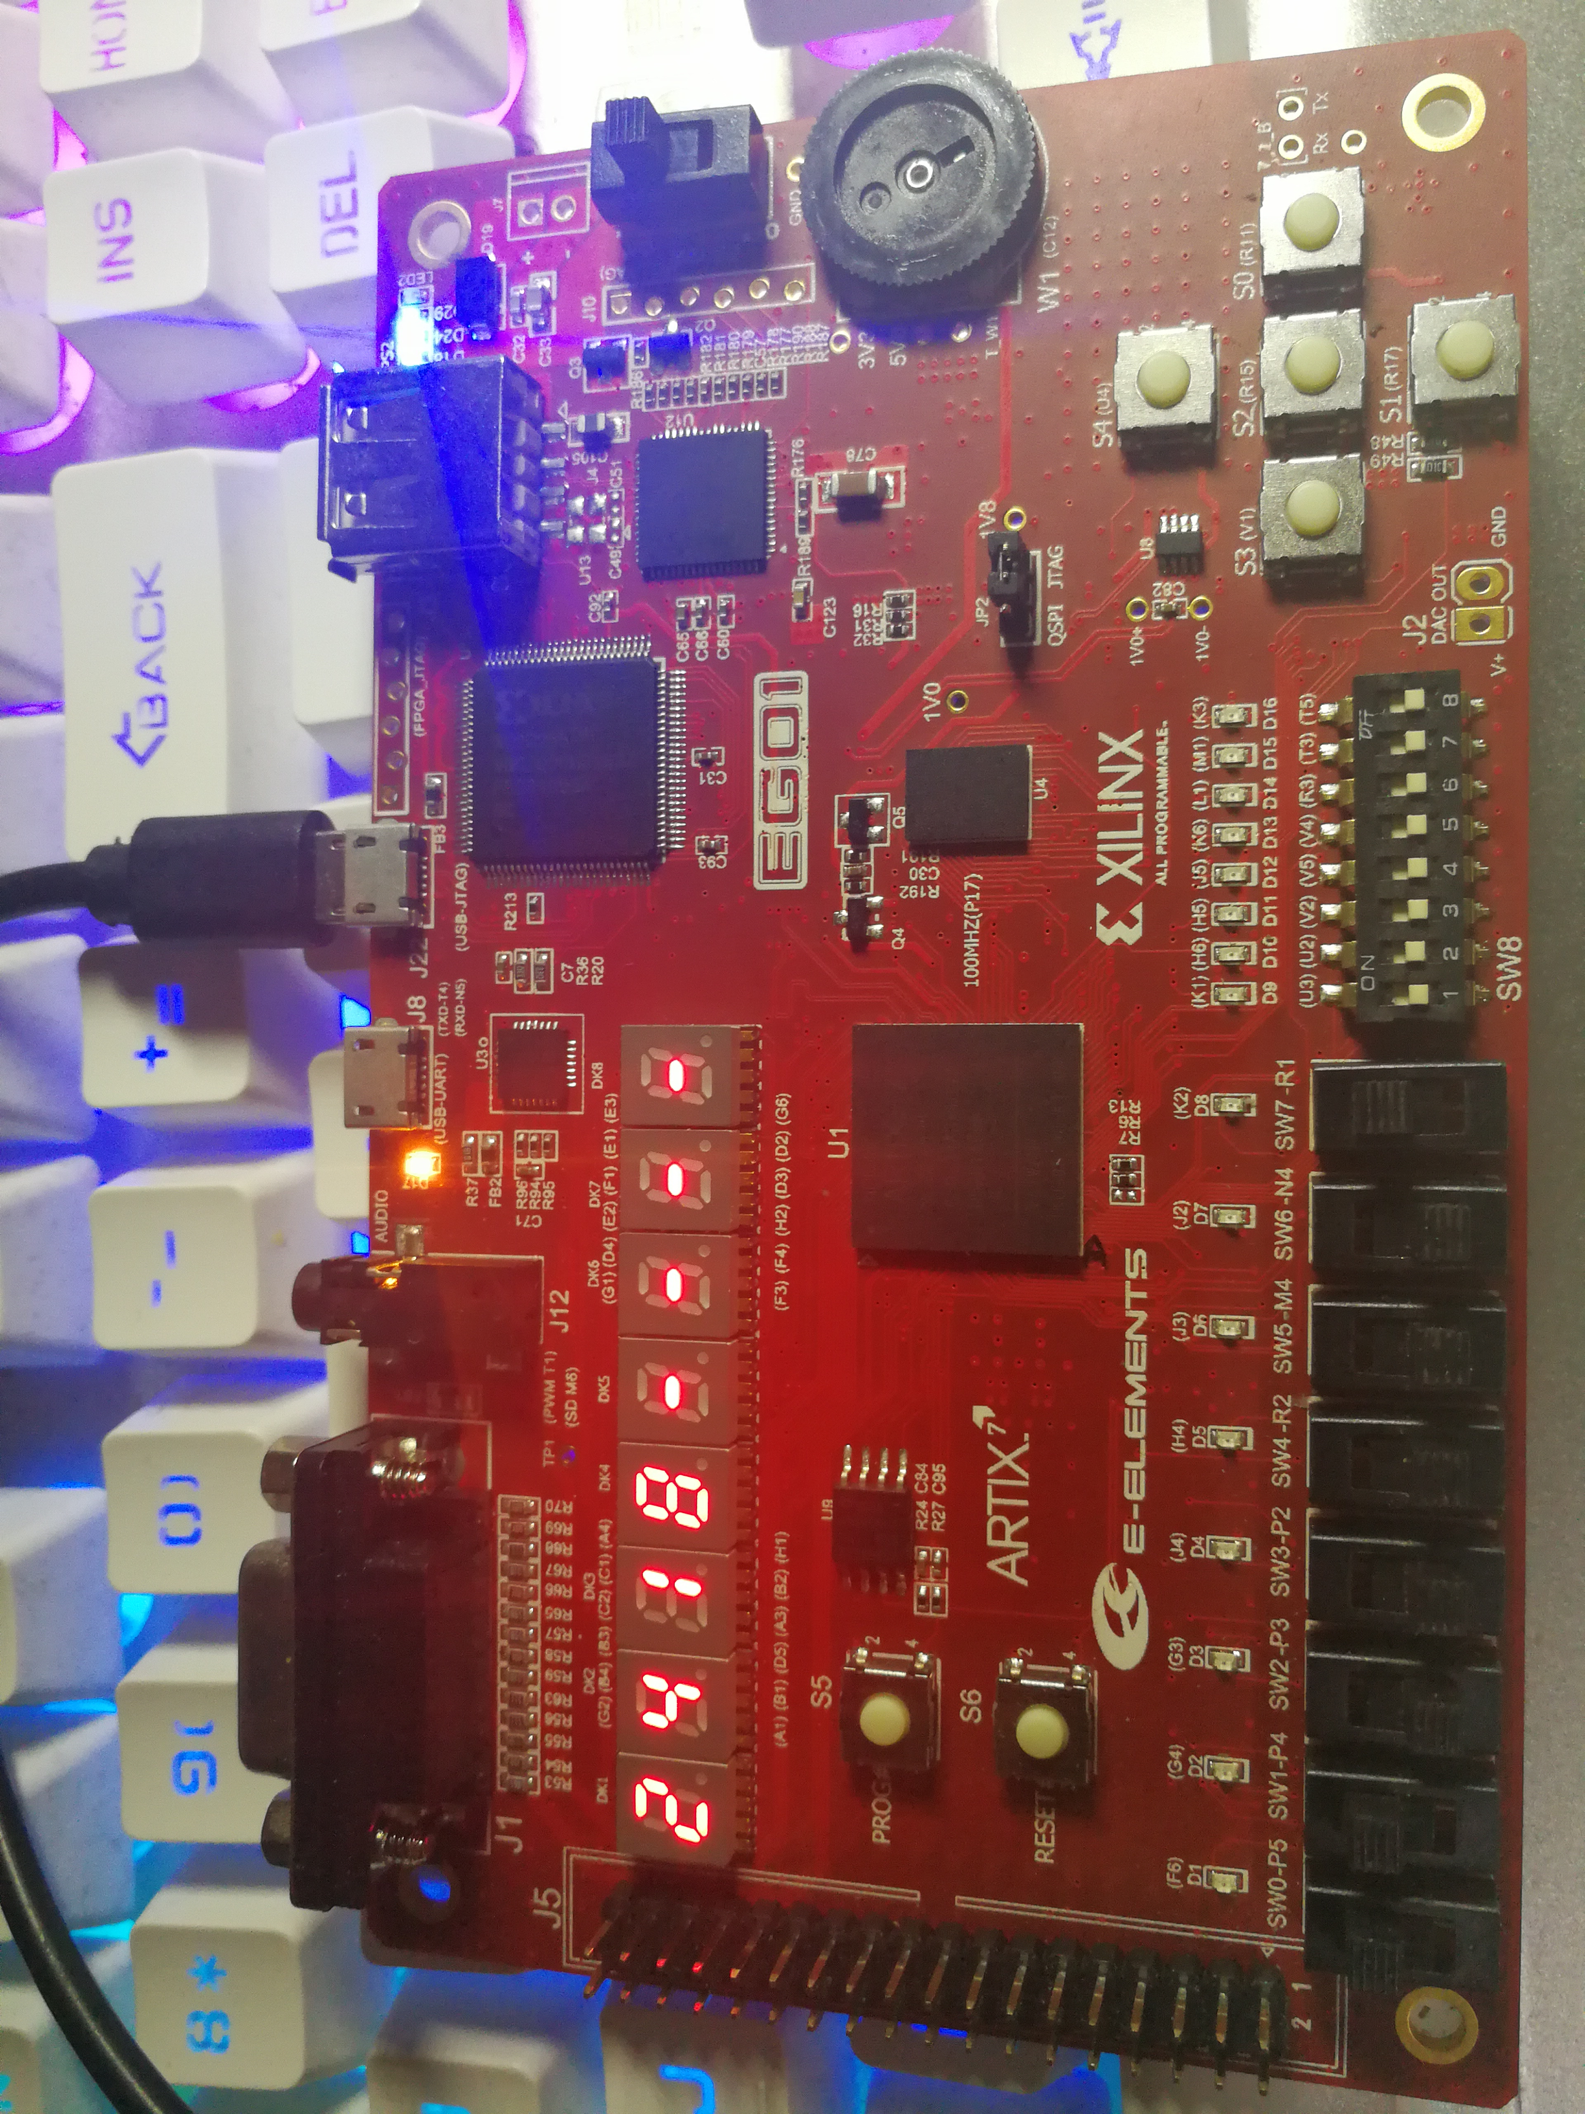

滚动显示

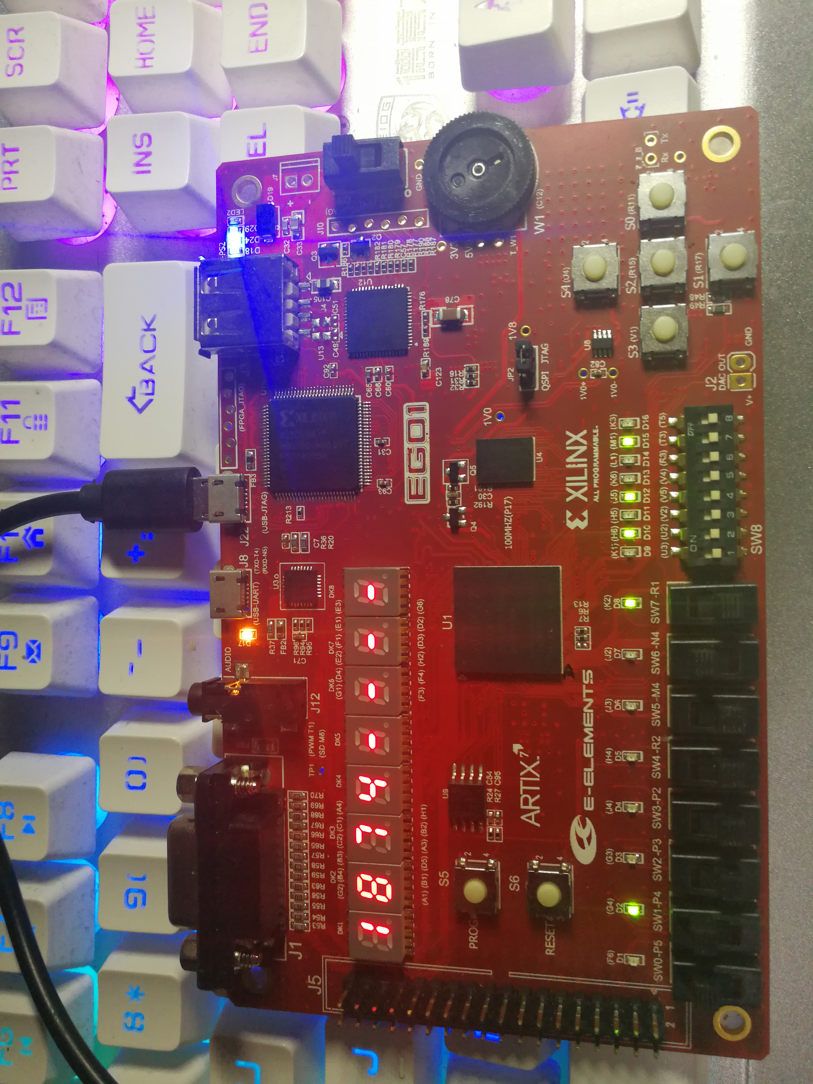

SRAM读取高4位数据

由图我们可以得到，我们能够分高四位与第四位数据输入学号，并完成学号滚动功能，同时我们能够将这八位学号分成两部分存入SRAM的两个不同地址并读出。

**五：结论（讨论）**

1.实验结论

学习了时序逻辑模块在数字系统中的综合应用与程序编写并且掌握实验平台的外部功能模块在数字系统设计中的应用。学习SRAM的使用，为设计复杂的数字电路，尤其是CPU设计奠定基础。

2.实验讨论

最初使用sram只是把sram当成寄存器，即存即取，并没有把数据真正存进sram中，经过代码改进最终实现了这一功能。数码管的高频错位显示的电路实现原理以及管脚约束的逻辑控制，以及sram静态高速存储器的使用原理和管脚分配使用约束属于本次实验的难点。

**六、教师评审**

|  |  |
| --- | --- |
| **教师评语** | **实验成绩** |
| 签名：  日期： |  |